Computer Architecture Lab
(EL-2012)
LABORATORY REPORT

Fall 2026

(Lab#05)
Use of Venus Simulator for Register Level Execution of RISC-V Control Instructions

Student Name: __Syed Sikandar Abbas__ Roll No: _24I-6553_ Section: CE-B

Date performed: ___16th September, 2026

MARKS AWARDED: ________ / 10

Signature and date of Instructor: _________________
Lab Instructors: Dr. Nasir Ali Shah, Engr. Fasih Ahmad

______________________________________________________________________________________________________________________________________________________

NATIONAL UNIVERSITY OF COMPUTER AND EMERGING SCIENCES, ISLAMABAD
Prepared by: | Fasih Ahmad |  | Version: 1.0
Verified by: | Dr. Nasir Ali Shah |  | Updated: Fall 2026

Task 1:

Description:
In this task, we were required to find out which instructions are actual instructions and which are pseudo-instructions, from table 1 and table 2. All the instructions that are written in assembly language and can be compiled, have a syntax, are all called actual instructions. They have their own op-codes which interact directly with hardware. Psuedo-instructions are for human understanding. All the comments in table 1 and 2, starting with # are called pseudo-instructions
Code:
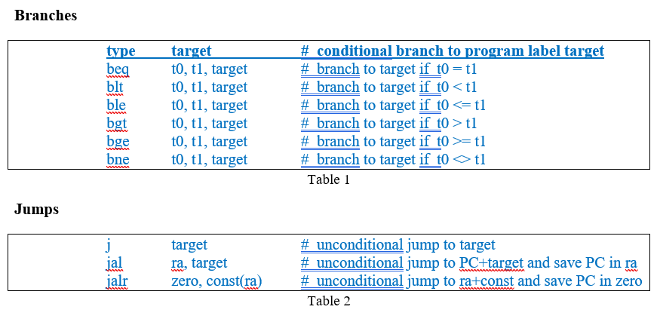
Output:
Actual Instructions:  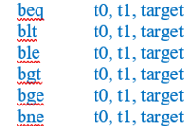  From Table 1    From Table 2 | Psuedo-Instructions:  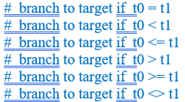  From Table 1  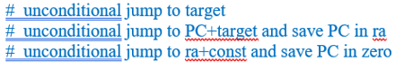  From Table 2

Task 2:

Description:
This task was supposed to write a code using beq and j instructions. The written code checks if s0 and s1 are equal. If they are, add s1 and s0 and jump to end. If not, subtract s0 from s1 and store in s2.
Code:
.data
.text
.globl main
addi s0, s0, 4
addi s1, s1, 6
beq s0, s1, Fin
True:
add s2, s1, s0
j end
Fin:
sub s2, s1, s0
end:
Output:
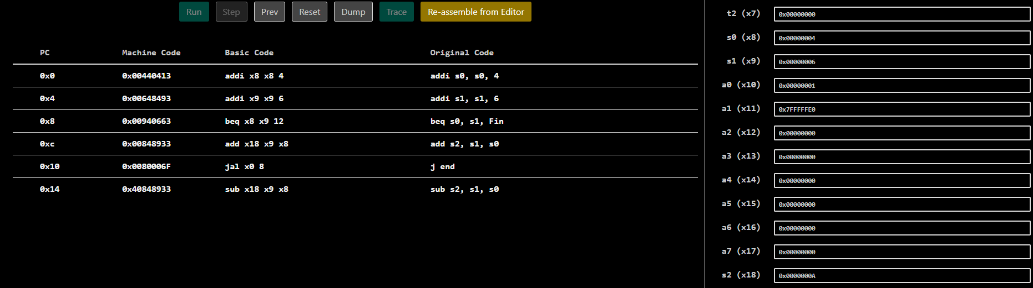

Task 3_1:

Description:
This task is a subset of task3. It provides us with a code which is supposed to be explained line by line which is done in the comments against each line in the code itself.
Code:
addi s0, s0, 4 # Loads the value '4' in s0
addi s1, s1, 6 # Loads the value '6' in s1
beq s0, s1, Fin # if (s0 == s1) branch to Fin, in our case 4 == 6 that’s false, the True Block will execute.
True: # Start of True block
add s2, s1, s0 # add the values of s1 and s0 and store in s2. s2 = s1 + s0. s2 = 6 + 4 = 10
j end # jump to end regardless of everything
Fin: # Start of Fin block
sub s2, s1, s0 # Subtract the value of s1 from s0 and store in s2. s0 = s1 - s0
end: #End of the code
Output:
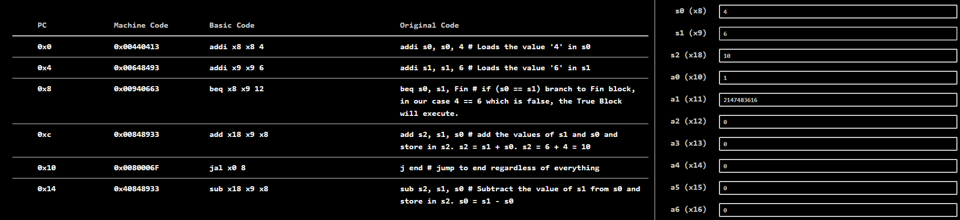

Task 3_2:

Description:
This task is a subset of task3. It provides us with a code which is supposed to be explained line by line which is done in the comments against each line in the code itself.
Code:
addi s0, s0, 4 # loads value '4' in register s0
addi s1, s1, 4 # loads value '4' in s1
beq s0, s1, Fin # if (s0 == s1) goto Fin else goto True;
True: # Start of True block
add s2, s1, s0 # add s1 and s0 and store in s2. s2 = s1 + s0
j end # branch to End block (end of code) regardless of everything
Fin: # Start of Fin block
sub s2, s1, s0 # subtraction: s2 = s1 - s0
End: # End of code
Output:
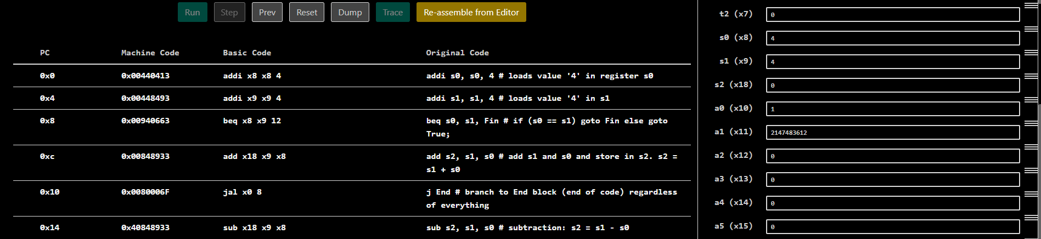

Task 4:

Description:
In this task, we were given a C program and asked to convert it into its equivalent assembly code.
Code:
.data
.text

.globl main
addi s1, x0, 5 # a = 5
addi s2, x0, 10 # b = 10
addi s4, x0, 4 # d = 4
addi s5, x0, 3 # e = 3
bne s1, s2, NotEqual
Equal:
sub s3, s4, s5
j End
NotEqual:
add s3, s4, s5
End:
Output:
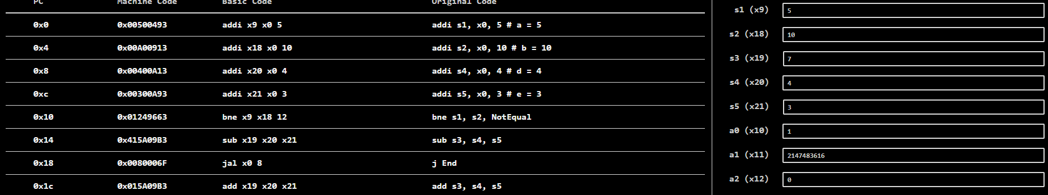

Task 5:

Description:
In this task, we were required to write a code that shifts a number by 2 and simulate it. We stored it in a saved register s0 and shifted that register by 2 and stored the result in another saved register s1, effectively multiplying the register s0’s value by 4. [2 * 4 = 8]
Code:
.data
.text

.globl main
addi s0, x0, 2
slli s1, s0, 2
Output:

Task 6:

Description:
In this task, we were given a pseudo-code resembling C-syntax. It was a for loop based code and its assembly equivalent code was to be written and simulated in venus.
Code:
.data
.text

.globl main
addi s0, x0, 0 # counter = 0
addi s1, x0, 1 # i
addi s2, x0, 5
for:
bgt s1, s2, end
addi s0, s0, 1
addi s1, s1, 1
j for
end:
Output:
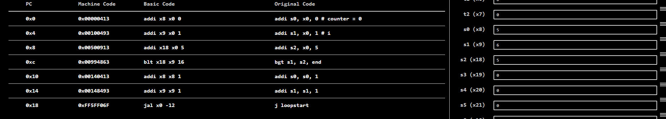

Task 7:

Description:
We were given a C-based while loop code that takes an array of integers, starts at the base of array and increments each array value by its index + 5. And stops at index 5. The original C code was a while-loop based code which didn’t have any line to increment the index. In case if the original code was run, it would be an infinite loop that kept on storing 0 + 5 = 5 in num[0] infinitely and would take us nowhere. I added the line by myself in the assembly code that cleanly runs the logic and stops when the loop condition becomes false.
Code:
.data
num: .word 0, 0, 0, 0, 0, 0, 0, 0, 0, 0
.text
.globl main
main:
li s2, 0 # i
li s3, 5 # max
WHILE:
bge s2, s3, ENDWHILE
addi s4, s2, 5 # value to be stored
la s5, num # go to the target location eg num[i]
li t1, 4
mul s6, s2, t1 # s6 = s2*t1 = i*4: to calculate the offset
add s5, s5, s6 # actual offset
sw s4, 0(s5) # num[i] = i + 5
addi s2, s2, 1 #this line was added to make the code work. It was not in the given C #snippet. Without this it would have been an infinite loop. C: i++;
j WHILE
ENDWHILE:
Output:
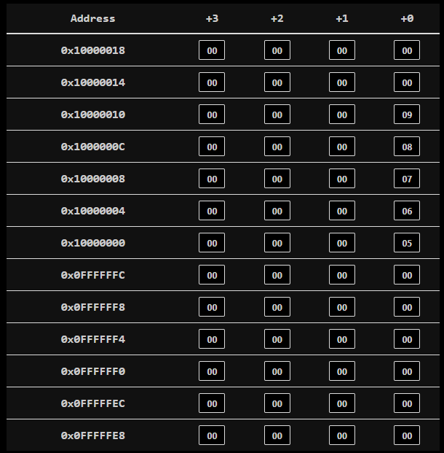
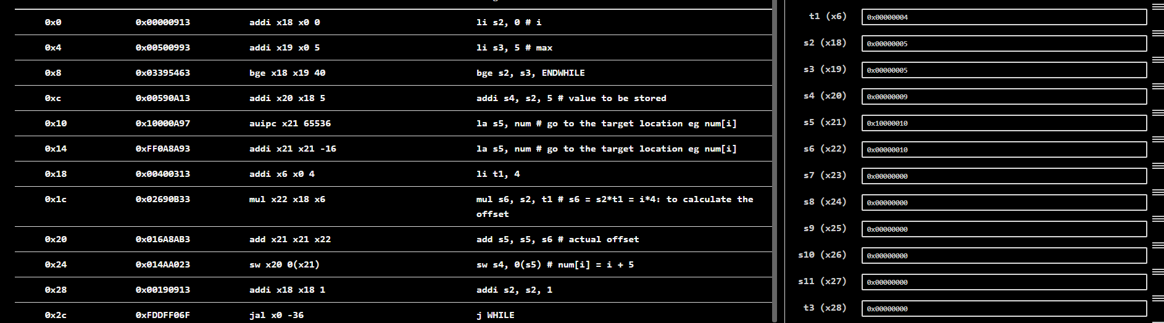

Task 8:

Description:
A nested loop C code was to be converted to RISC-V assembly and simulated using Venus.
Code:
.data
.text

.globl main
li s0, 0 # counter
li s1, 0 # x
li s3, 3
li s4, 2
for1:
bge s1, s3, end1
li s2, 0 # y
for2:
bge s2, s4, end2
add s0, s1, s2
addi, s2, s2, 1
j for2
end2:
addi s1, s1, 1
j for1
end1:
Output:
